Dubai Corporation for Ambulance Services
Primary Source Verification (PSV) Application Form - Private Sector
Application Type - Private Sector | The below form must be completed in English, with all entries typed in CAPITAL  LETTERS

Section 1: Personal Information

*Note: Enter full name as per passport or national ID (or as per alternative identity document - if applicable).

**Note: Provide maiden name (last name before marriage) where requested.

Last Name
First Name
Middle Name
Date of Birth (dd/mm/yyyy) |  | Country of Birth
Passport Number |  | Nationality
National ID Number |  | Gender | Male/Female
City |  | Email Address
Area |  | Country of Residence
Telephone Number (Mob./Res.)

Section 2: Education Information
Highest Tertiary Education Qualification
*Note: Provide full name and address of institution attended. Indicate clearly your qualification and exact name and address of qualifying body. Do not use abbreviated terms or initials.

Full Name as per Certificate
 | (If full name on certificate is different than full name on passport, submit relevant name change document)
University/Institution Name
College Name
University Address
City |  |  | Area
University Country |  |  | Telephone Number
Qualification Attained
Major Subject |  |  | Minor Subject
Student/Enrollment Number
Seat/Registration Number
Attendance Period | From (dd/mm/yyyy) |  | To  (dd/mm/yyyy)
Qualification Conferred Date (dd/mm/yyyy)

Section 3: Professional Qualification Information
Highest Tertiary Professional Qualification
*Note: Provide full name and address of institution attended. Indicate clearly your qualification and exact name and address of qualifying body. Do not use abbreviated terms or initials.

Full Name as per Certificate
 | (If full name on certificate is different than full name on passport, submit relevant name change document)
University/Institution Name
College Name
University Address
City |  |  | Area
University Country |  |  | Telephone Number
Qualification Attained
Major Subject |  |  | Minor Subject
Student/Enrollment Number
Seat/Registration Number
Attendance Period | From (dd/mm/yyyy) |  | To (dd/mm/yyyy)
Qualification Conferred Date (dd/mm/yyyy)

Professional License/Health License (If Applicable)
Licensing Authority Name
City |  |  | Area
Country |  |  | Telephone Number
License Type
License Number
Validity Period | From (dd/mm/yyyy) |  |  | To (dd/mm/yyyy)
License Conferred Date (dd/mm/yyyy)

Section 4: Work Experience Details
*Note: Provide FULL details of employer for last 3 years - starting from most recent employer.
Employer Details
Company/Organization Name
Address
Website
Telephone Number |  |  | Employment Code
Period of Employment | From (dd/mm/yyyy) |  |  | To (dd/mm/yyyy)
Job Title/Designation |  |  |  | Department
Full Time/Temporary | (If temporary - please specify agency name, if any)
Employer Details
Company/Organization Name
Address
Website
Telephone Number |  |  | Employment Code
Period of Employment | From (dd/mm/yyyy) |  |  | To (dd/mm/yyyy)
Job Title/Designation |  |  |  | Department
Full Time/Temporary | (If temporary - please specify agency name, if any)
Employer Details
Company/Organization Name
Address
Website
Telephone Number |  |  | Employment Code
Period of Employment | From (dd/mm/yyyy) |  |  | To (dd/mm/yyyy)
Job Title/Designation |  |  |  | Department
Full Time/Temporary | (If temporary - please specify agency name, if any)
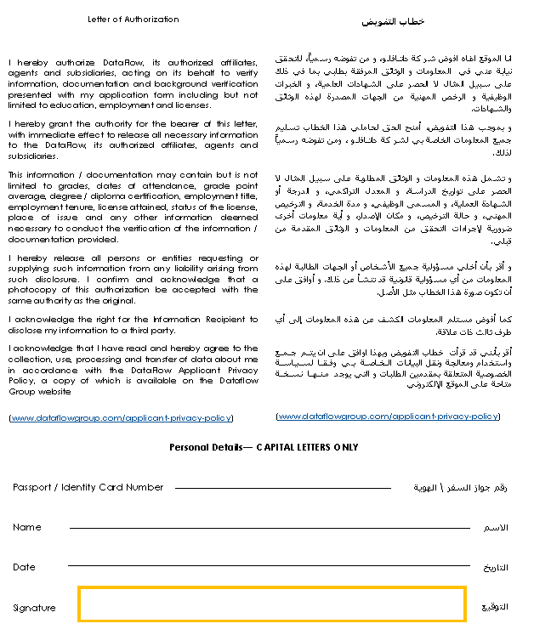
Checklist
The following information and documents are mandatory, and your application will not be processed if they are not provided. Please submit clear and legible copies - indicating the university logo where applicable. |  | Submitted
1 | Duly filled application form
2 | Signed Letter of Authorization
3 | Valid Passport Copy
4 | Name Change Certificate - if applicable (marriage certificate, affidavit or any legal document)
5 | Qualification certificate(s) copy (original and translated)
6 | Mark sheet for final year (mark sheet for full year for applicants who studied in India)
7 | Certificate of Authentication and Verification (CAV) (for applicants who have studied in the Philippines)
8 | Copy of back page of degree certificate (for applicants holding degree certificates issued from Afghanistan, Egypt and Pakistan)
9 | Experience letter(s) from previous employers
10 | Professional license/health license - if applicable

Signature
- I hereby confirm that the above information is complete, true and accurate.

- I hereby confirm that I will cooperate with the DataFlow Group to provide the required documents and information as needed.

Applicant Signature:

Date of Application:

